**Variables:**

It is a container for storing data values.

A variable is assigned with a data type.

int a=10;

**Variable Declaration**:

DataType variableName = VariableValue;

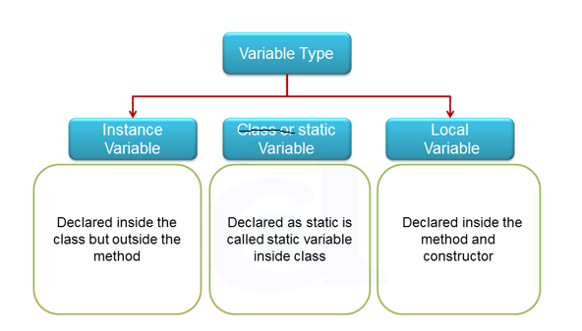

**Types**:

**Local Variable:**

* + - Local variable must be inside the method.
    - its lifecycle will be **throughout the method**.
    - we **must initialize the local variable**.

**Class Variable or Instance variable:**

* + - class Variable must be outside the method and inside the class.
    - its lifecycle will be throughout the class.
    - Accessing is done through the **Object**
    - no need to initialize the class variable.
    - if we not initialize the value the default value of the given datatype which will be printed.
    - if we give local and class variable as a same reference name the **priority go to local variable**.

**Static Variable:**

* + - static Variable must be outside the method and inside the class.
    - Once we declare the **variable as static** and **method as static without using the object**, we can call the static variable and static method.
    - its lifecycle will be throughout the class.
    - if we not initialize the value the default value of the given datatype which will be printed.
    - in class variable we can use static keyword but we cannot give static in local variable.